**Justice Party of Pennsylvania**

**Financial Report for June 2013**

**Prepared By:**   
Aaron Morris  
Treasurer

July 3, 2013

**Summary- June 2013**

**Balances**

|  |  |  |
| --- | --- | --- |
| **Account** | **Beginning Balance (on June 1)** | **Ending Balance (on June 30)** |
| Checking (Orrstown Bank) | $167.94 | $187.06 |
| PayPal | $0.00 | $0.00 |
| **Total** | **$167.94** | **$187.06** |

**Cash Flow**

|  |  |
| --- | --- |
| **Beginning Balance** (on June 1) | **$167.94** |
| Receipts |  |
| *Monetary (e.g. .cash, check, credit card)* | *$20.00* |
| *In-Kind* | *$0.00* |
| Total Receipts | $20.00 |
| Disbursements |  |
| *Operating Expenses* | *$0.88* |
| *Refunds* | *$0.00* |
| Total Expenses | $0.88 |
| **Net Change** | **$19.12** |
| **Ending Balance** (on June 30) | **$187.06** |

**Financial Analysis for June 2013**

**Income vs. Expenses by Category – June 2013**

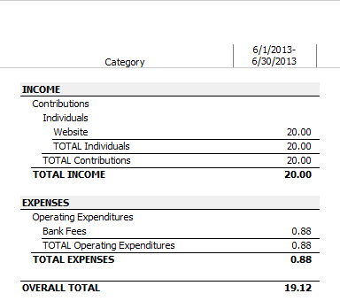

**Income vs. Expenses by Payee – June 2013**

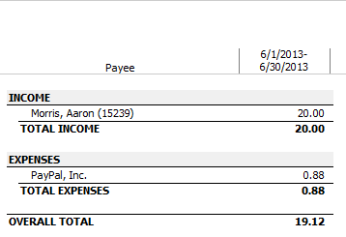

**Financial Analysis for Year-to-Date**

**Income vs. Expenses by Category – YTD (Quarterly)** 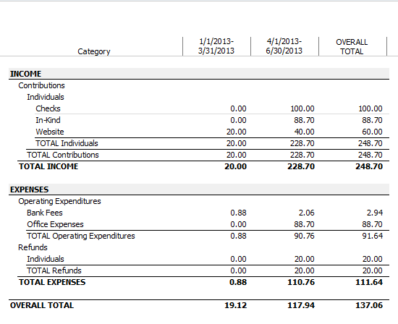

**Income vs. Expenses by Payee – YTD (Quarterly)** 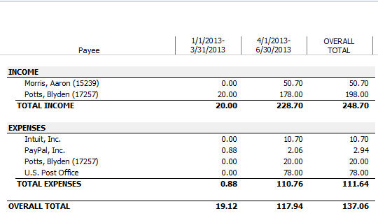

**Appendix A:   
Audit of Checking Account**